COVID-19 situation report for WHO Africa Region

10/04/2020

Produced by the TIBA COVID-19 Epidemic Response Unit

# Section 1: Overview of WHO Africa situation

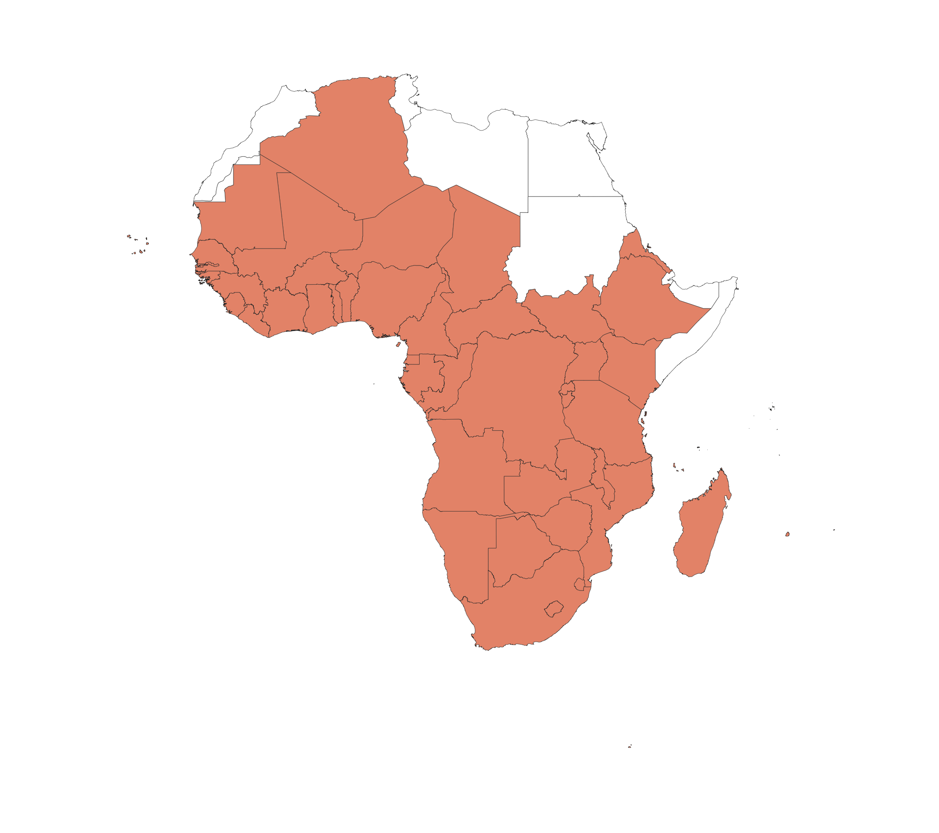

We compare the size and rate of increase of the COVID-19 epidemic across the countries included in WHO Africa Region.

The maps below summarise the in-country situations:

* Top row: cumulated reported cases (left) and deaths (right).
* Middle row: cumulated reported cases (left) and deaths (right) per 10,000 population on a log10 scale.
* Bottom row: overview of doubling time of cumulative incidence (left) and deaths (right). Doubling times are estimated over a 7 day period up to 06/04/2020.

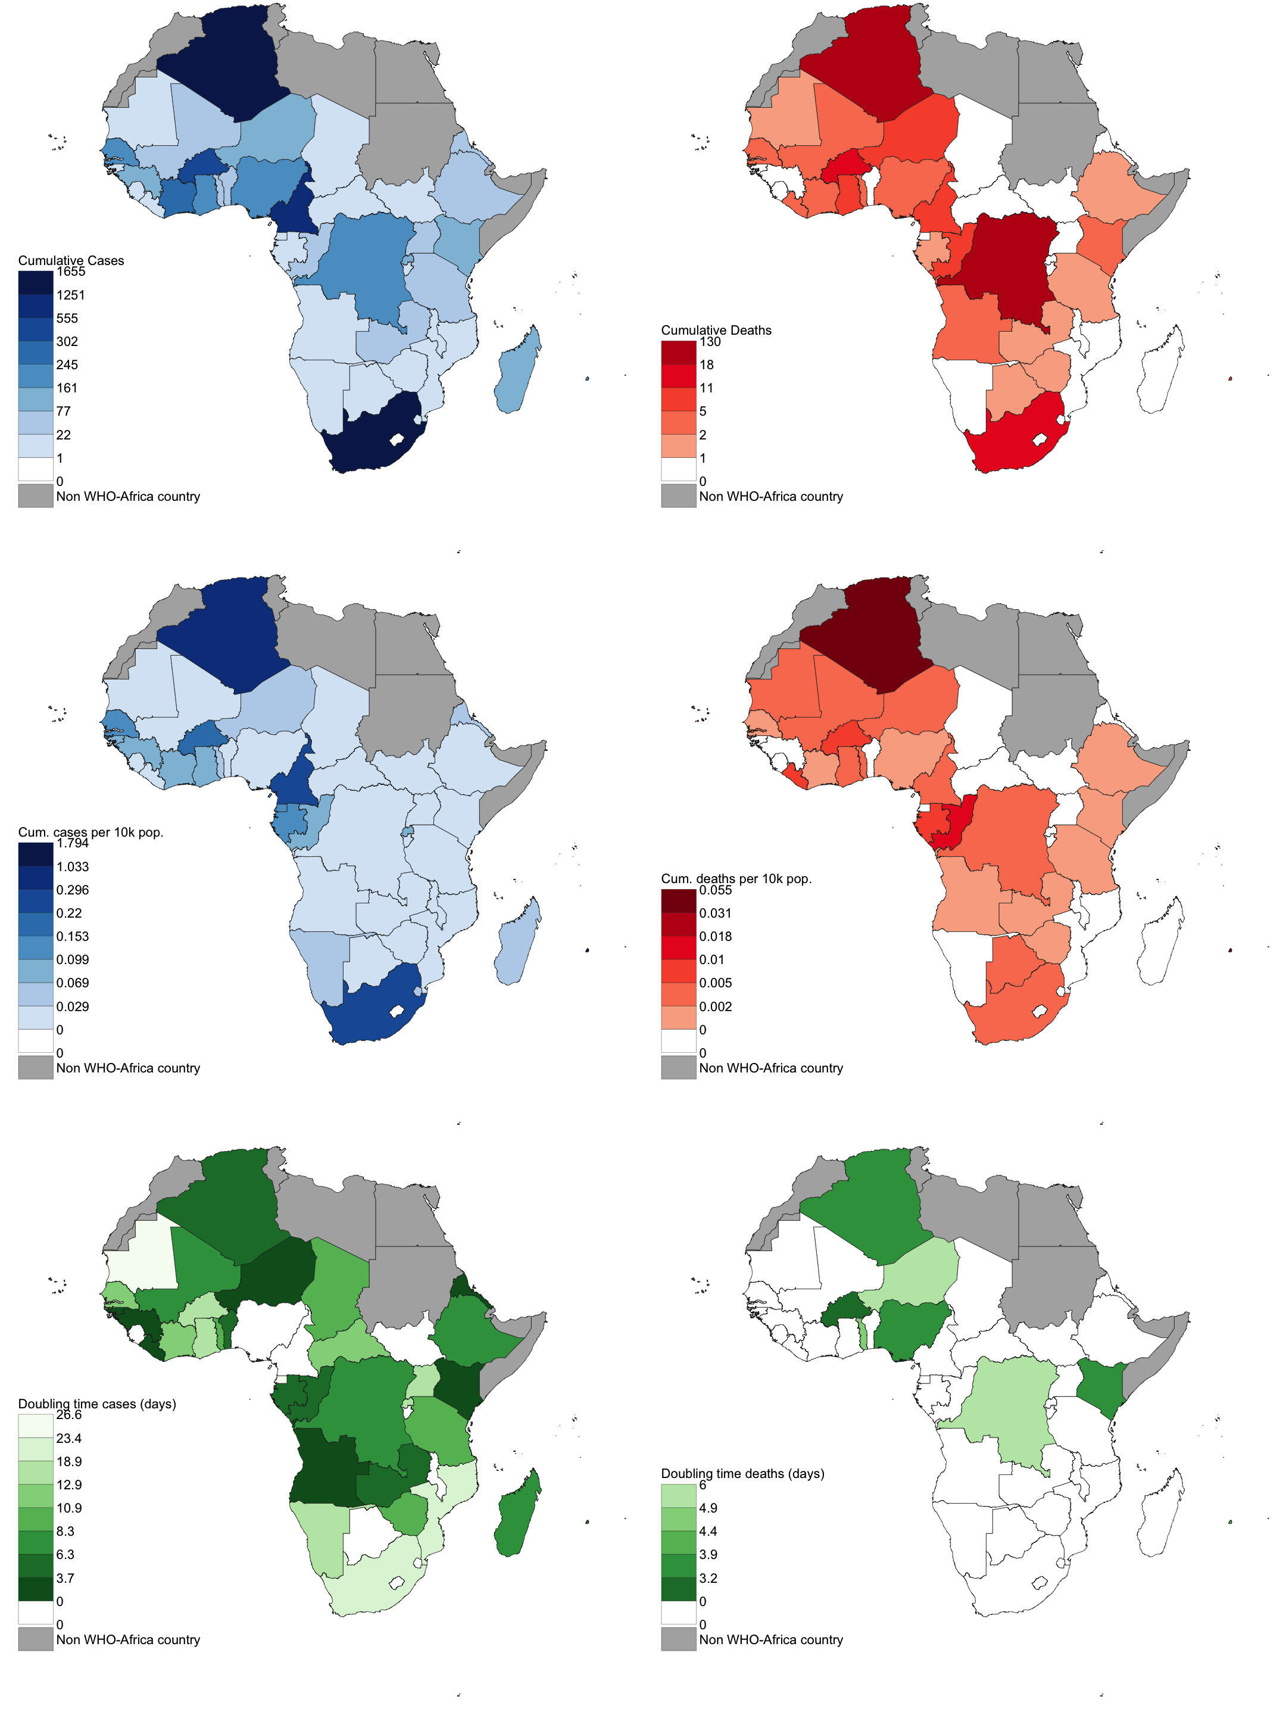

# Section 2: Individual countries situations

As of 06/04/2020, each panel below shows for each country:

* Top row: cumulated reported cases (left) and deaths (right).
* Middle row: cumulated reported cases (left) and deaths (right) per 10,000 population on a log10 scale.
* Bottom row: log10 increase in number of cases (left) and deaths (right) based on the doubling times (of incidence and deaths respectively) estimated over a 7 day period up to 06/04/2020.

## Algeria

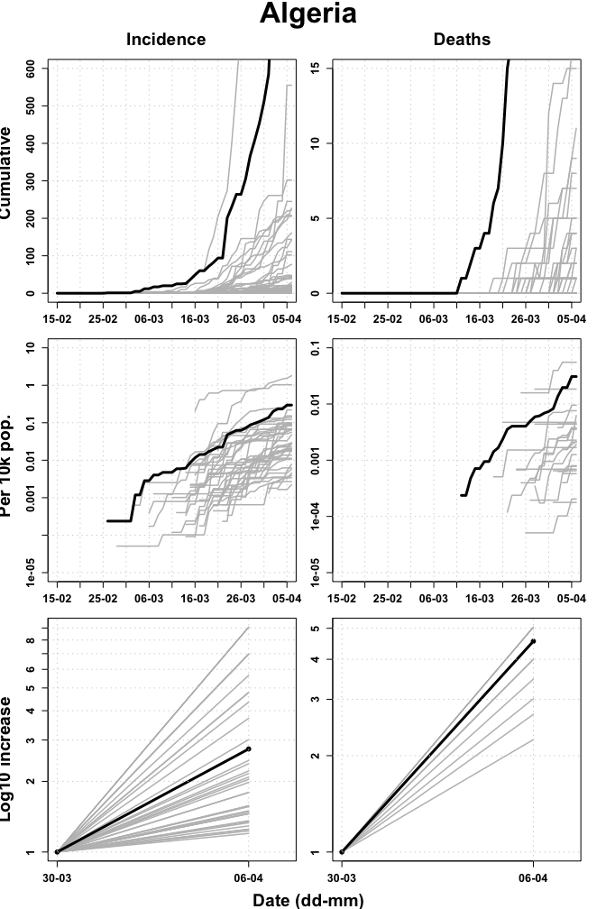

## Angola

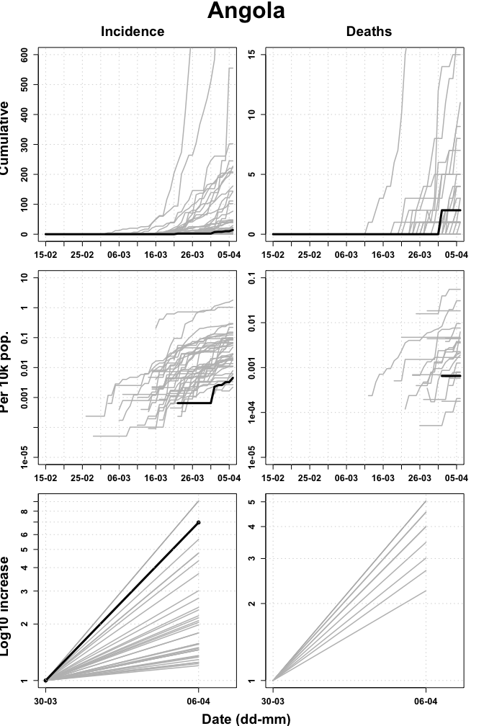

## Benin

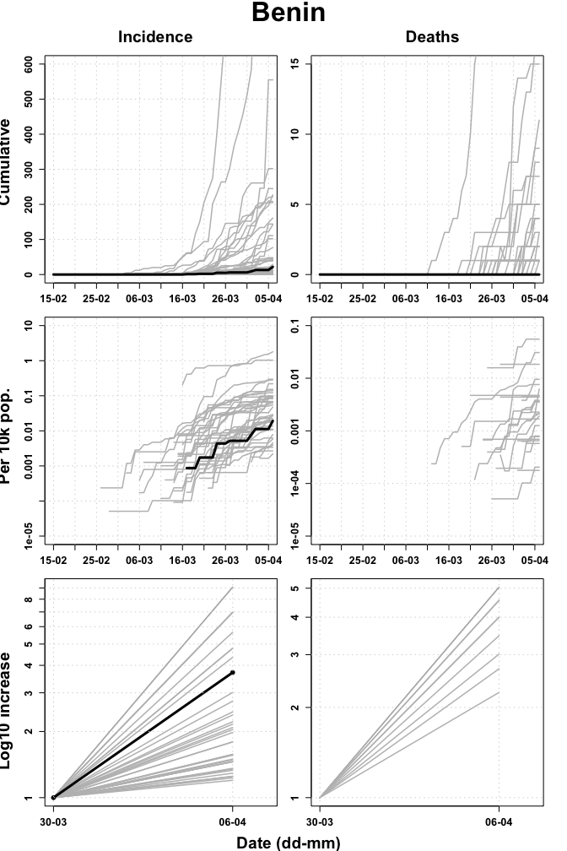

## Botswana

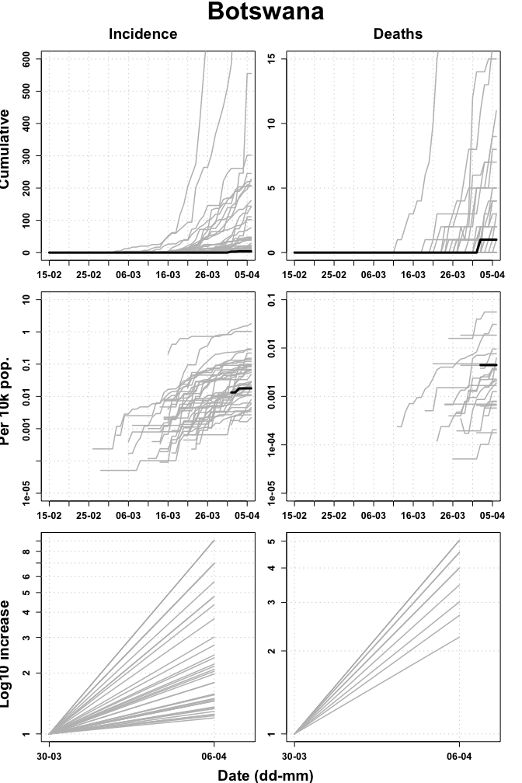

## Burkina Faso

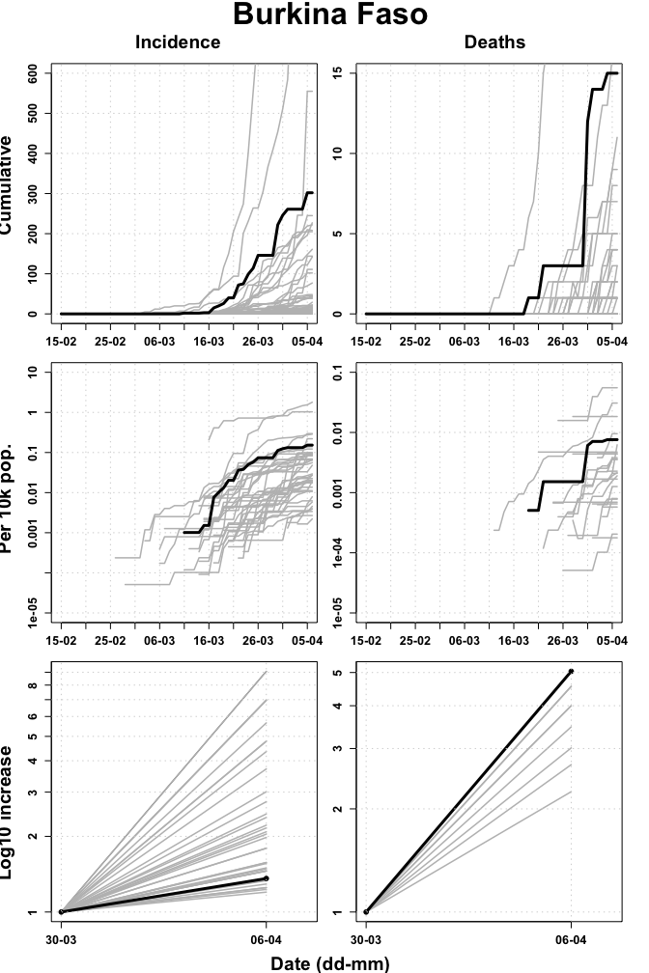

## Burundi

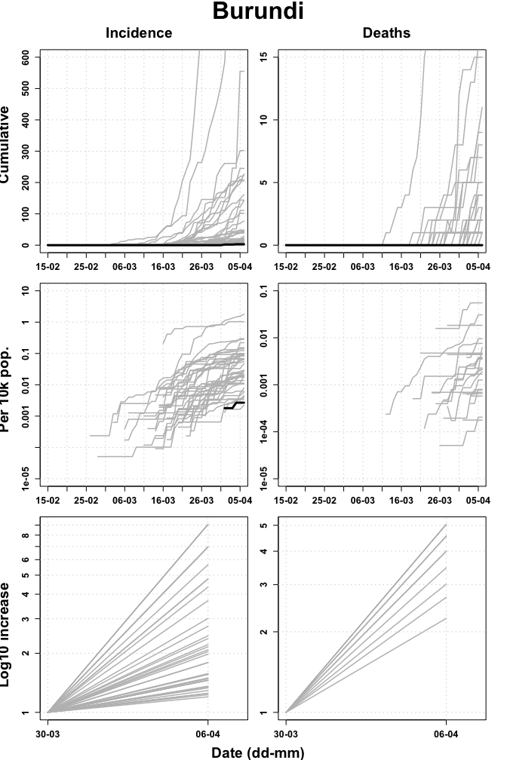

## Cameroon

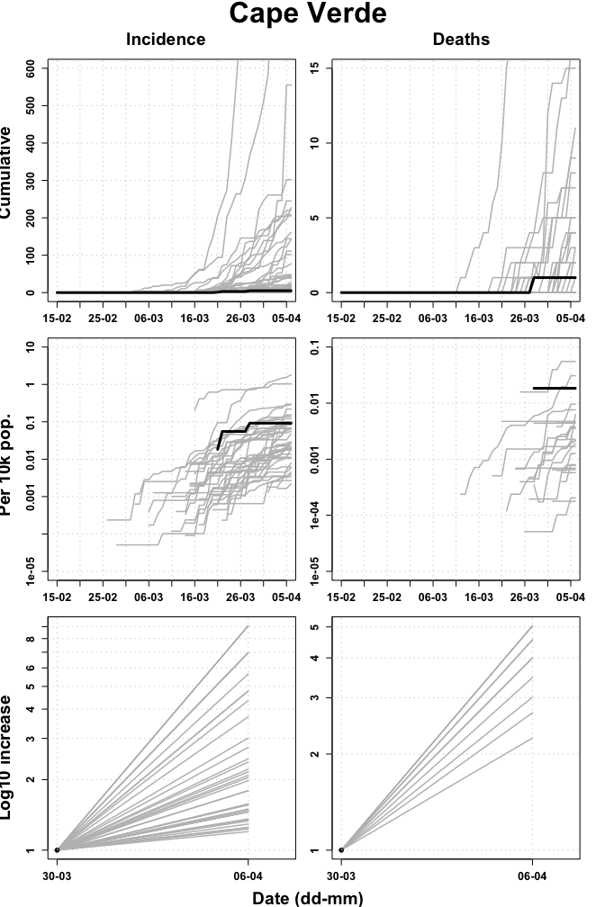

## Cape Verde

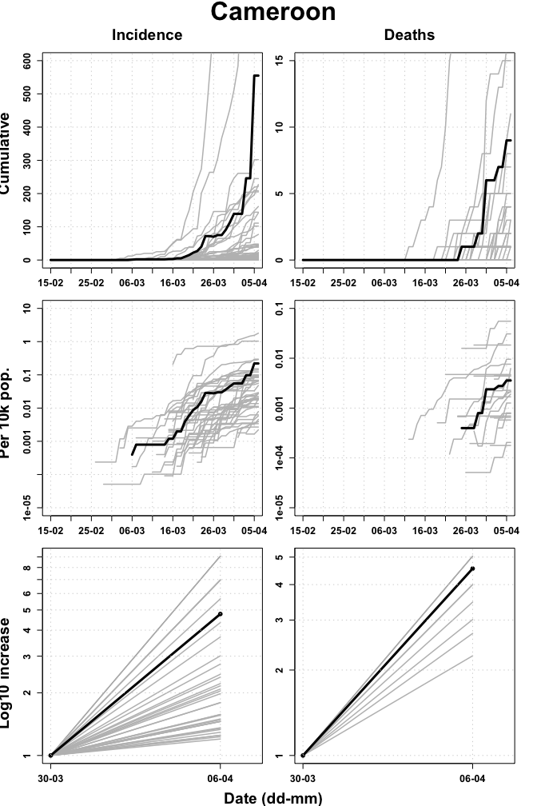

## Central African Republic

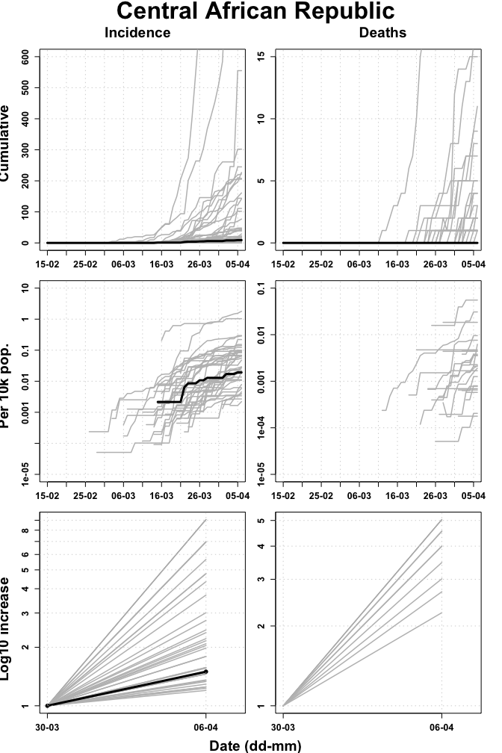

## Chad

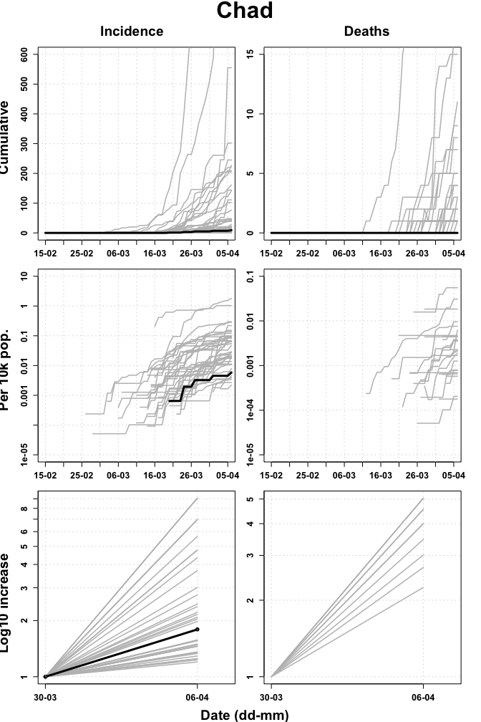

## Comoros

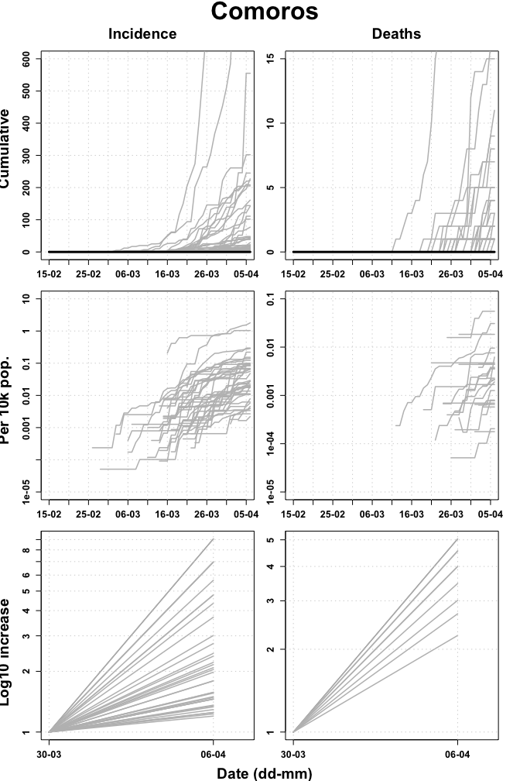

## Congo

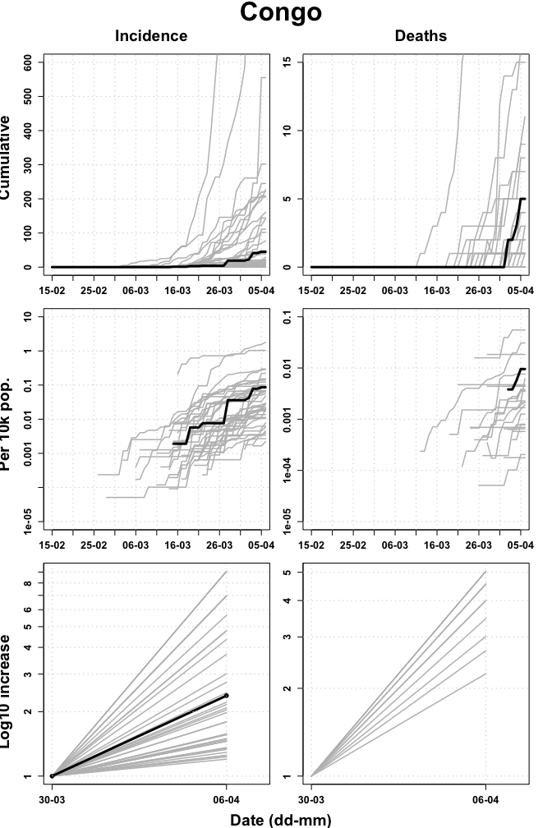

## Cote d’Ivoire

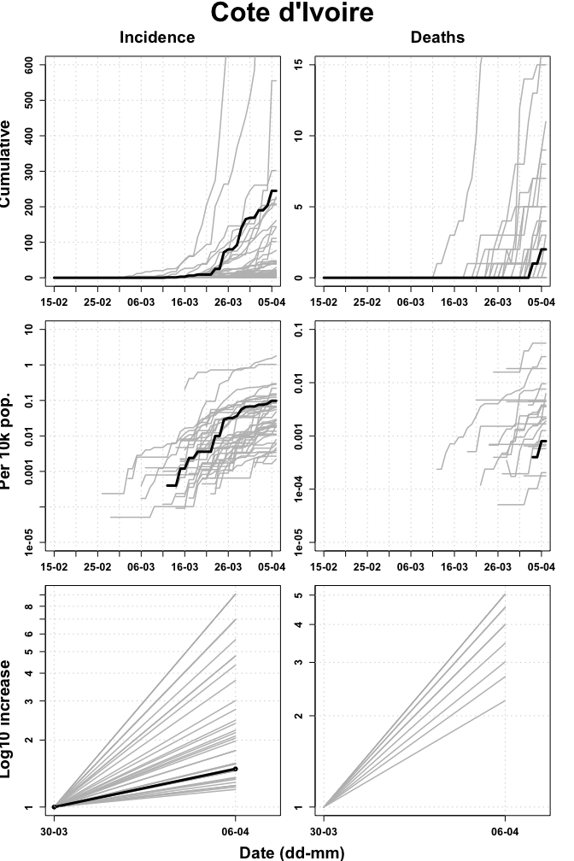

## Democratic Republic of the Congo

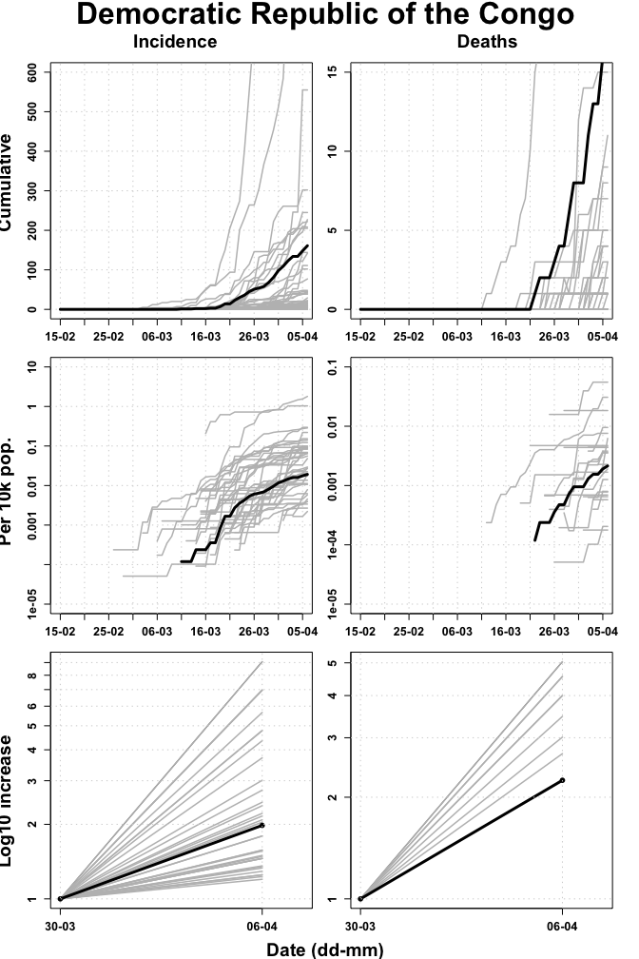

## Equatorial Guinea

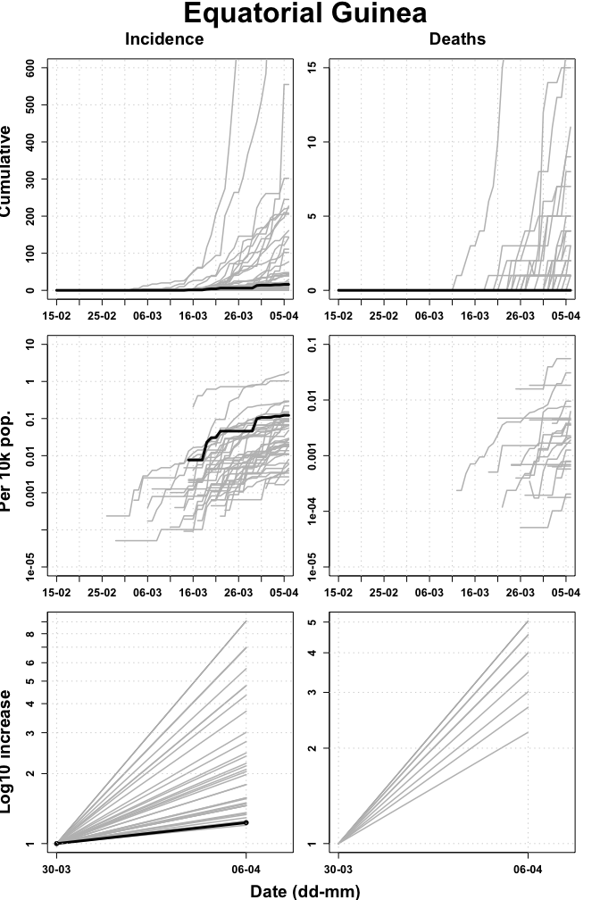

## Eritrea

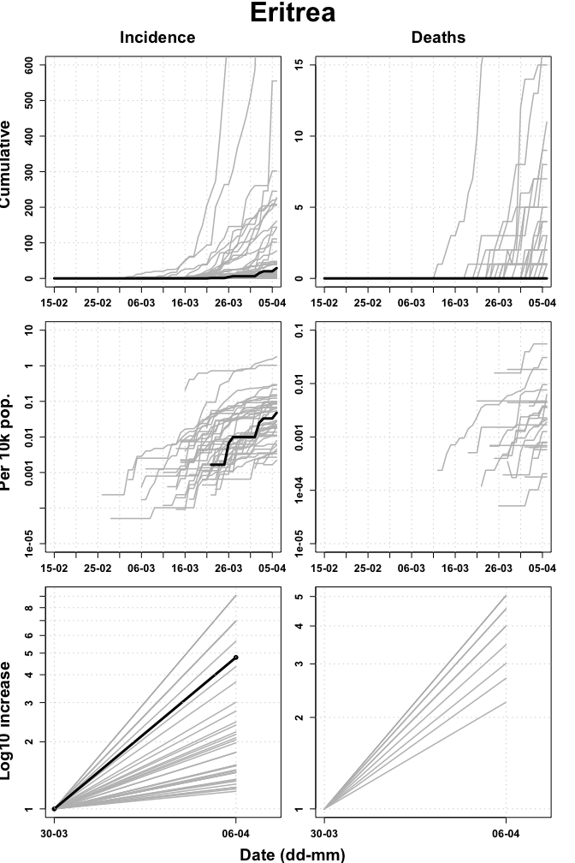

## Eswatini

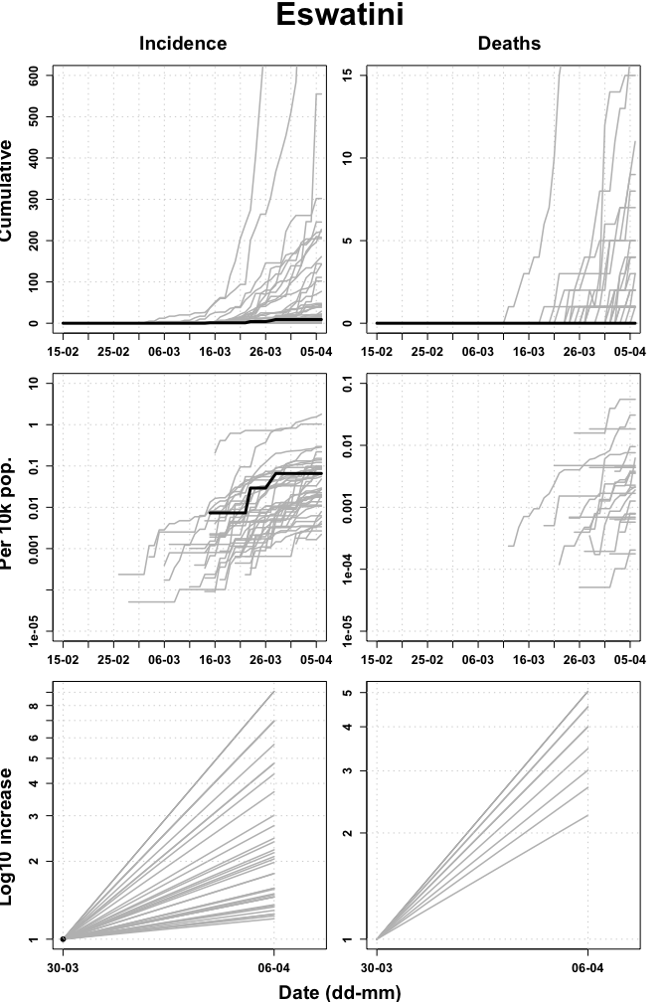

## Ethiopia

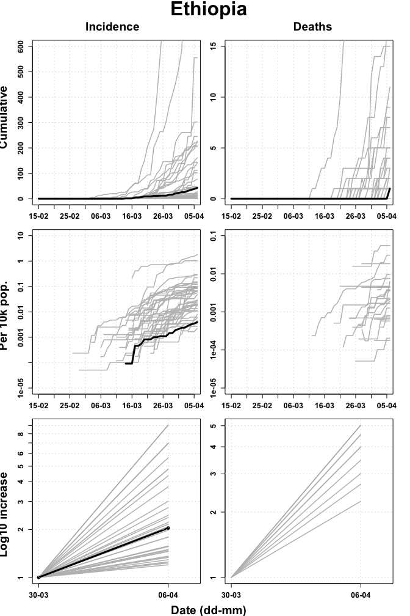

## Gabon

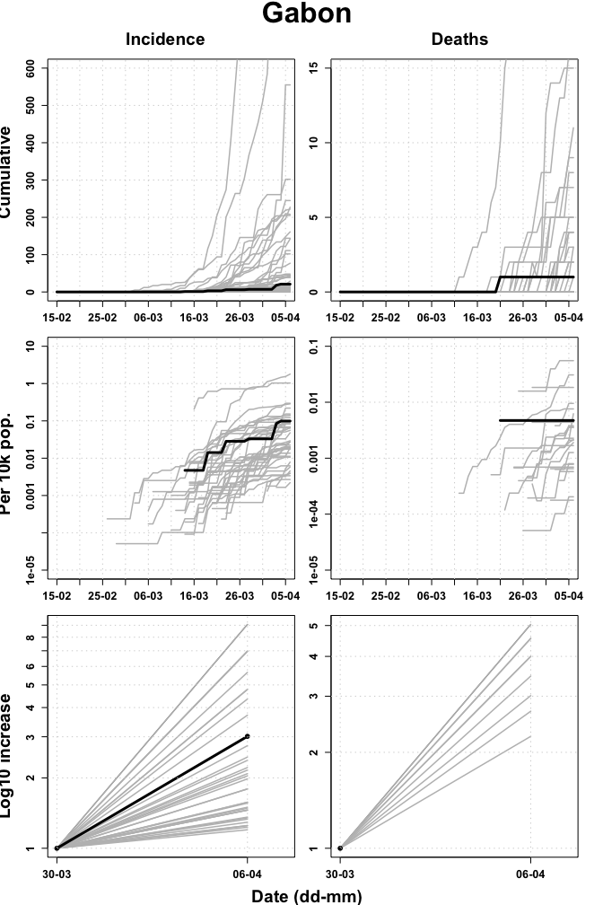

## Gambia

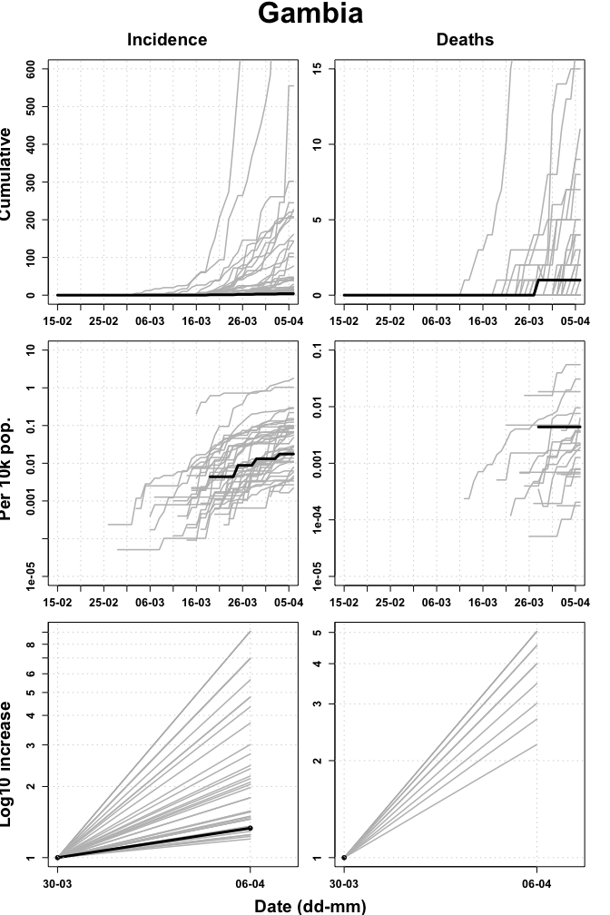

## Ghana

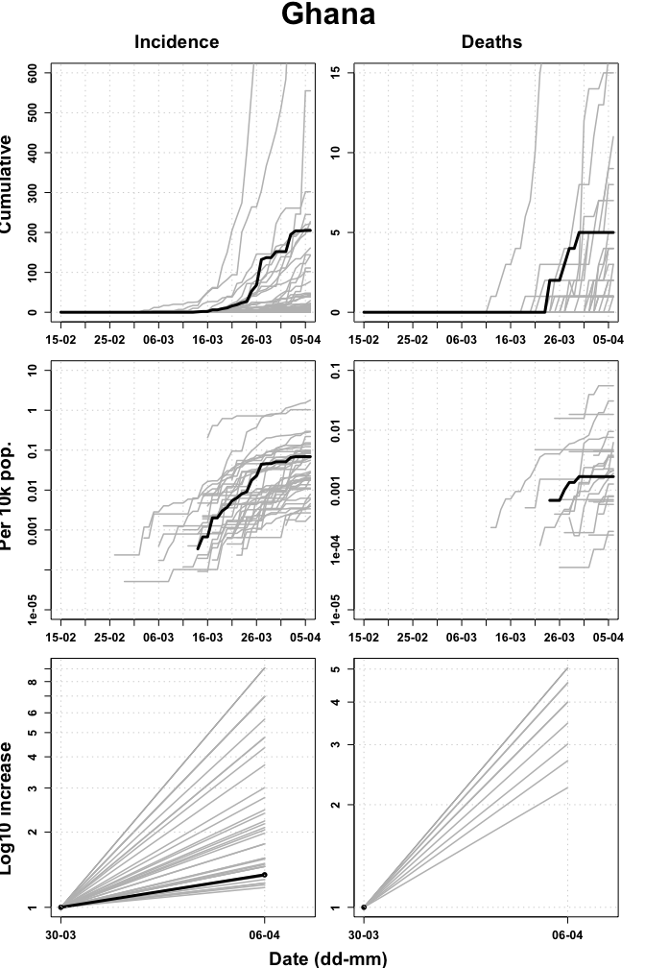

## Guinea

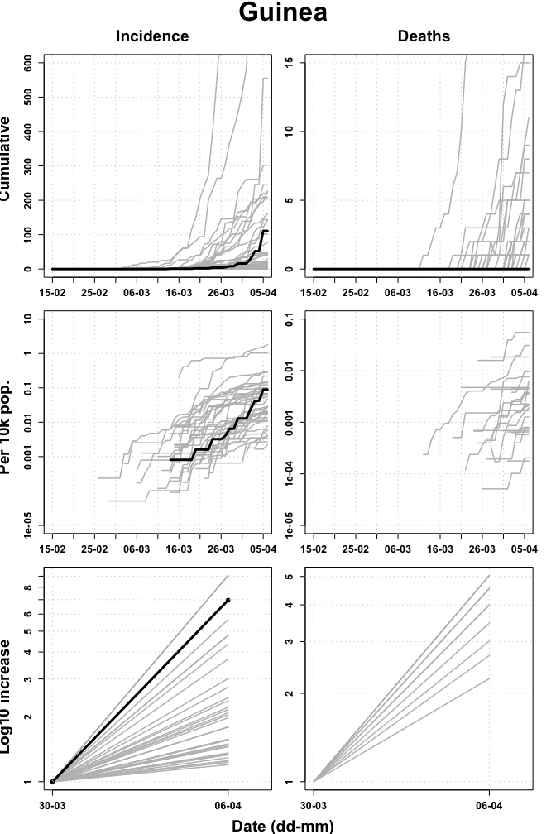

## Guinea Bissau

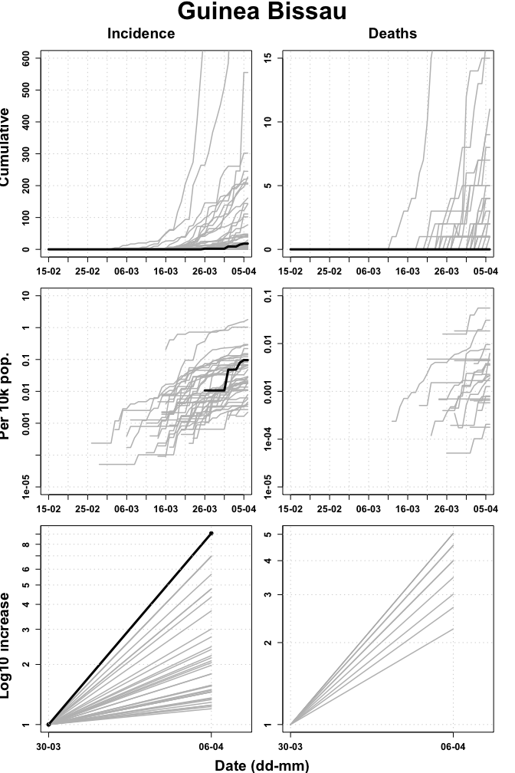

## Kenya

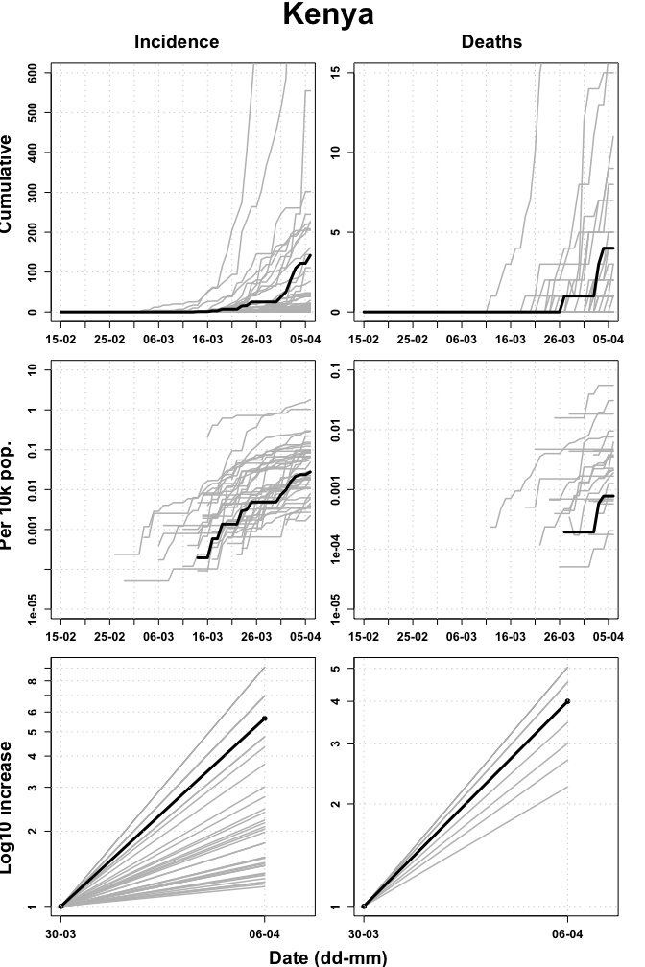

## Lesotho

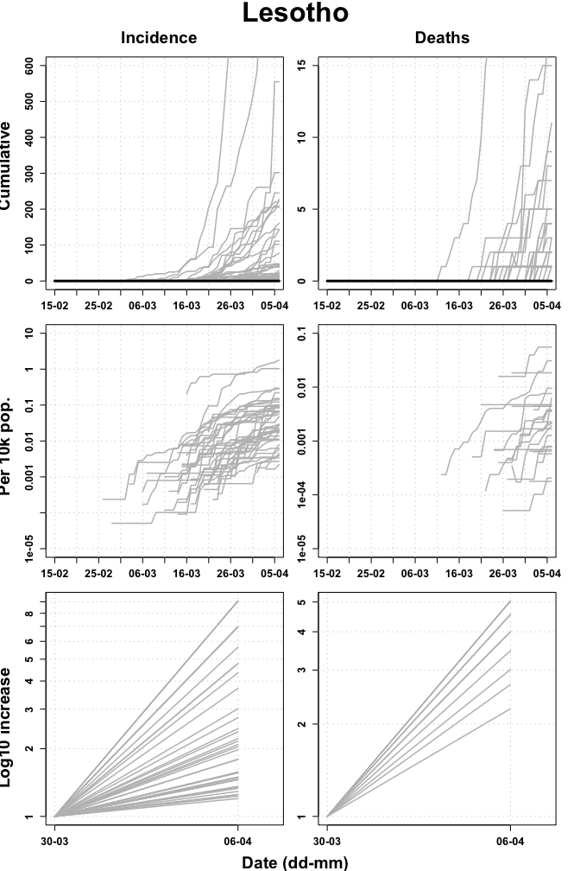

## Liberia

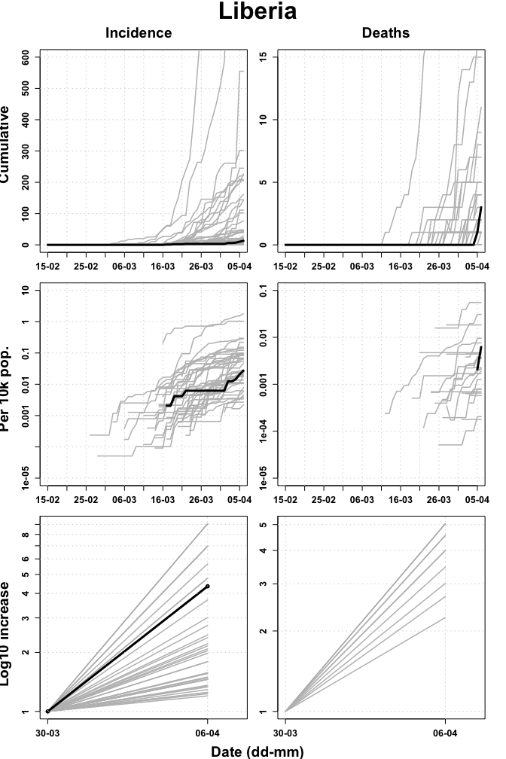

## Madagascar

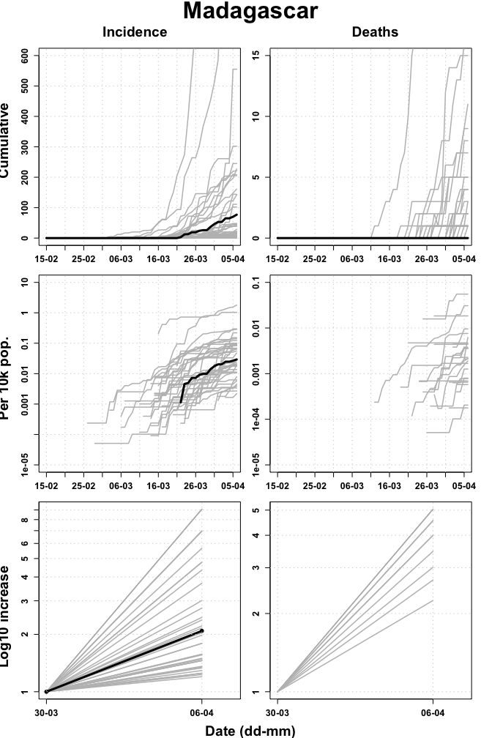

## Malawi

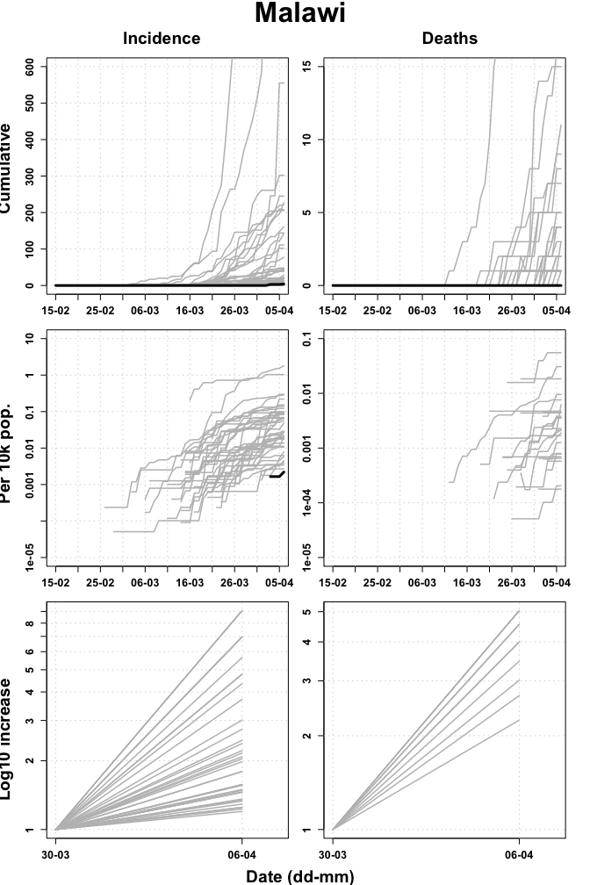

## Mali

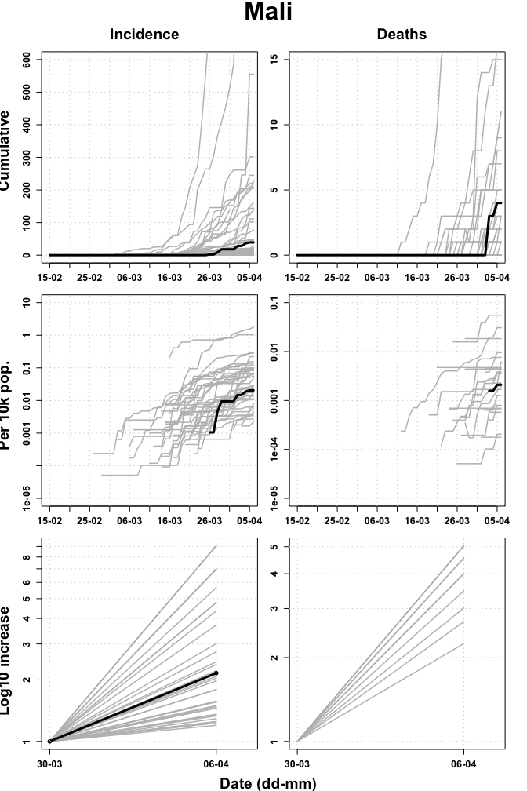

## Mauritania

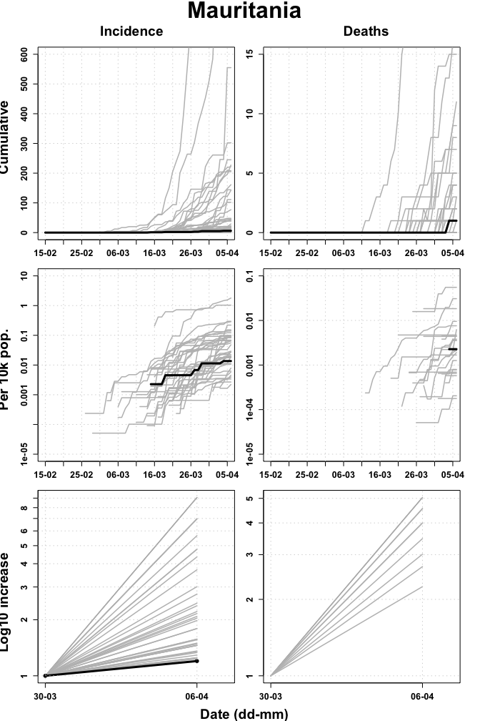

## Mauritius

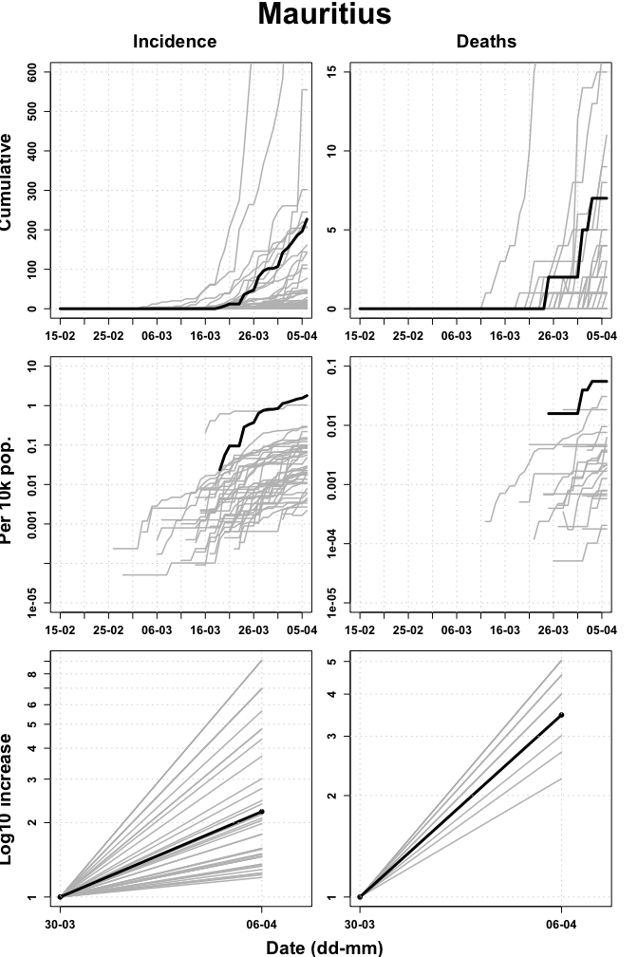

## Mozambique

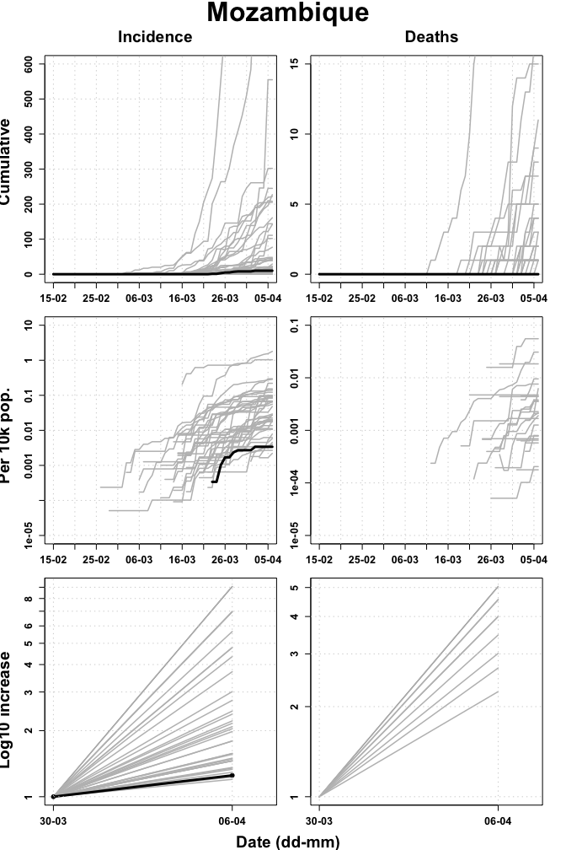

## Namibia

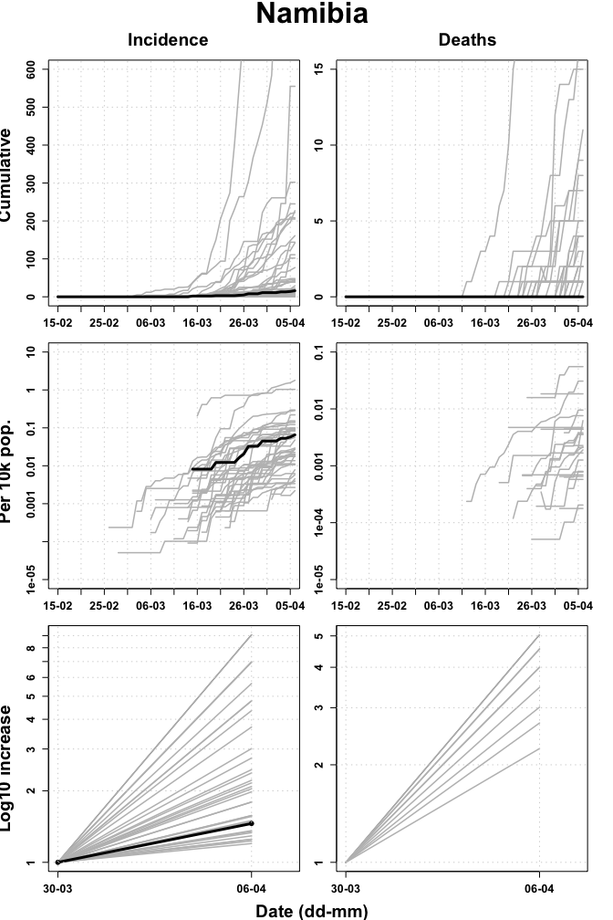

## Niger

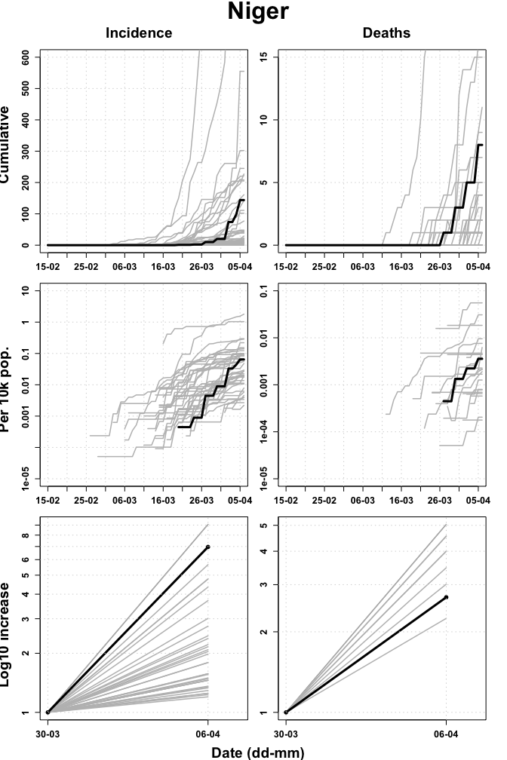

## Nigeria

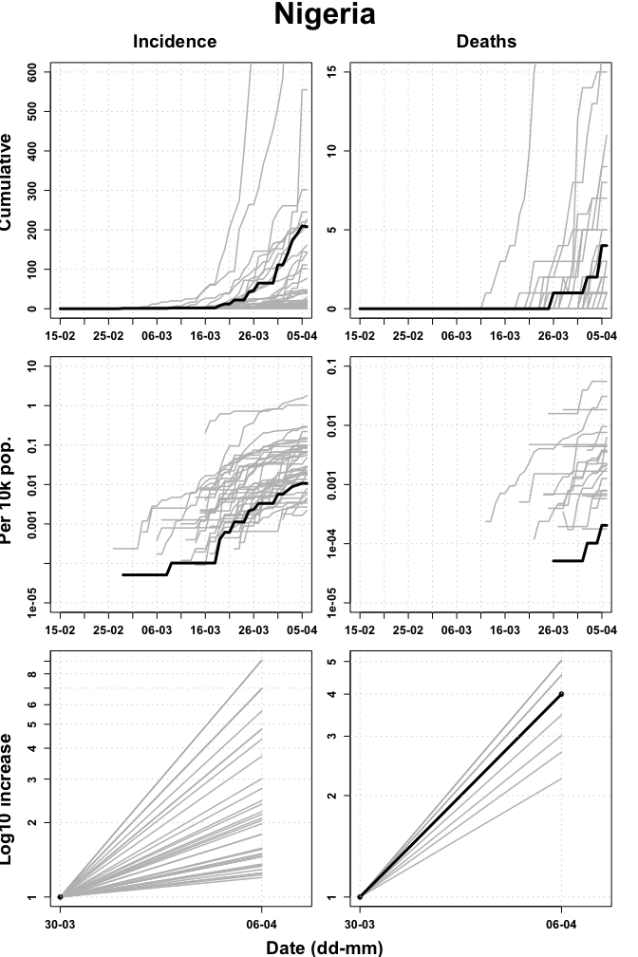

## Rwanda

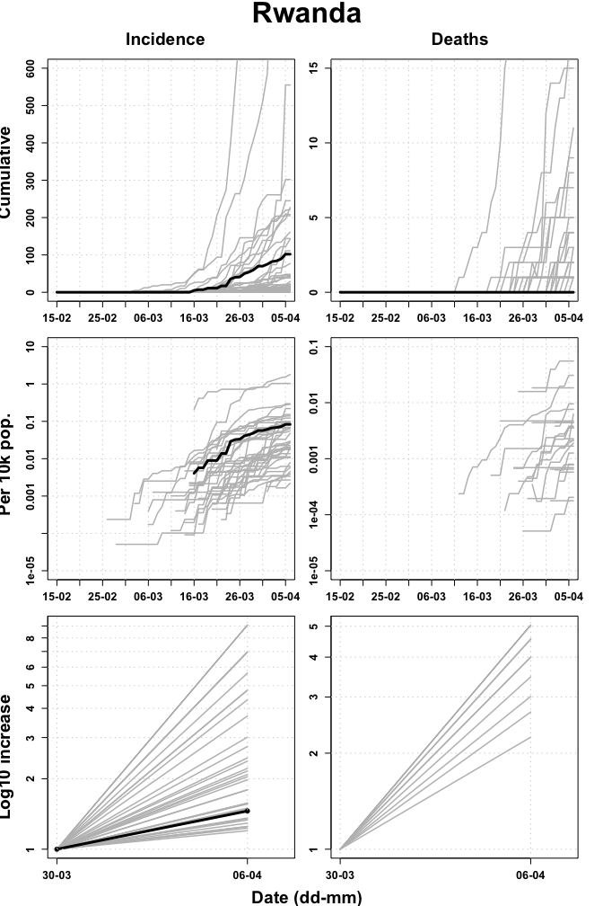

## Sao Tome y Principe

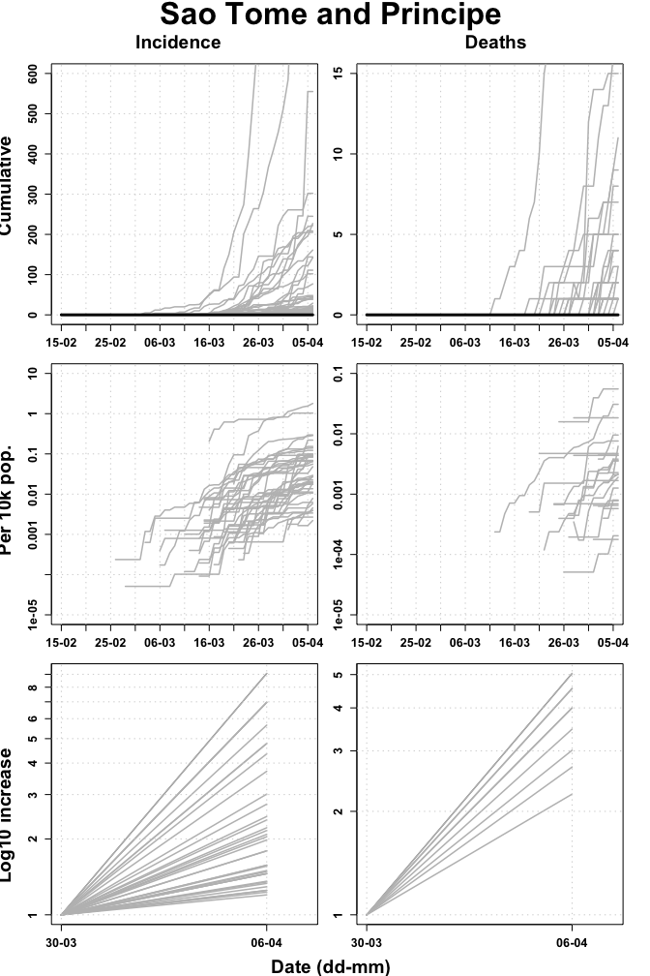

## Senegal

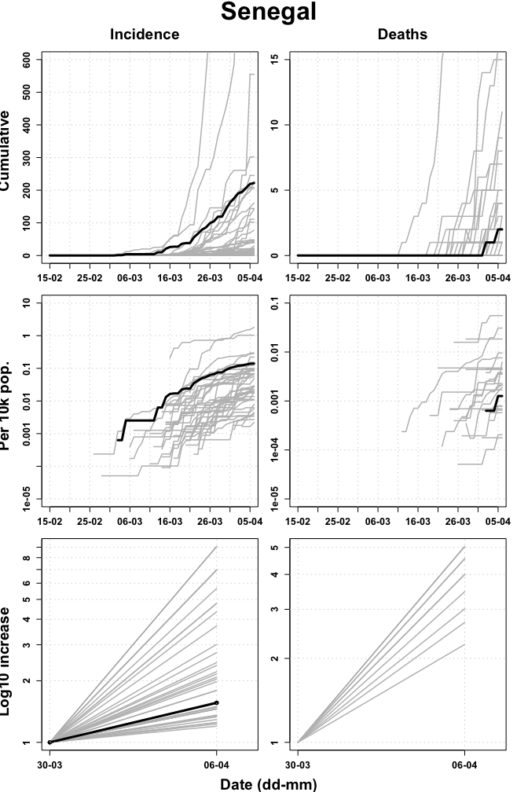

## Seychelles

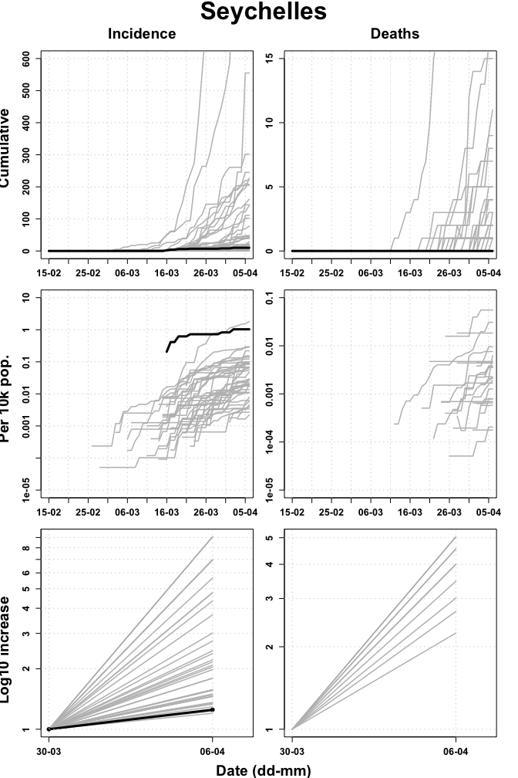

## Sierra Leone

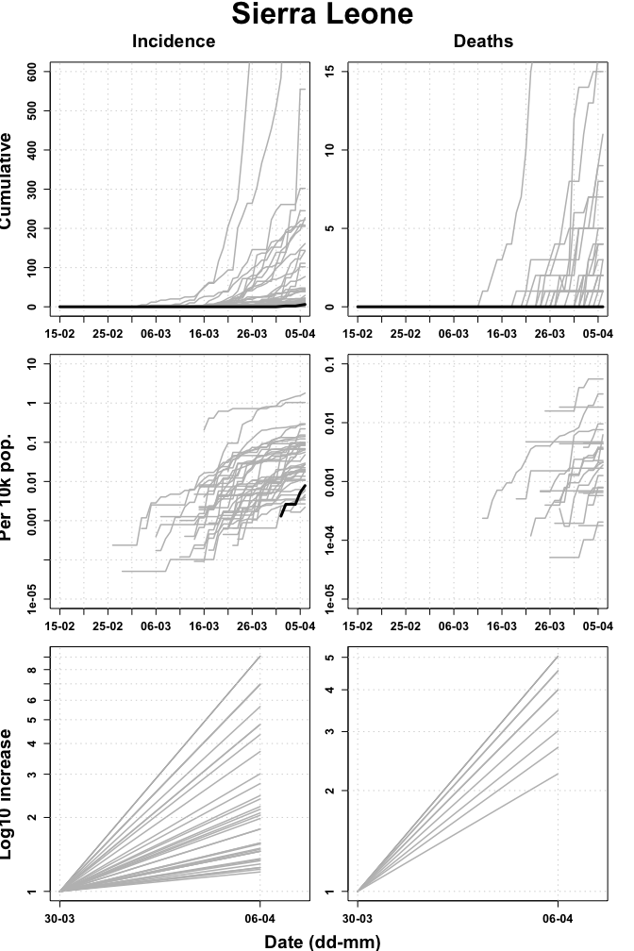

## South Africa

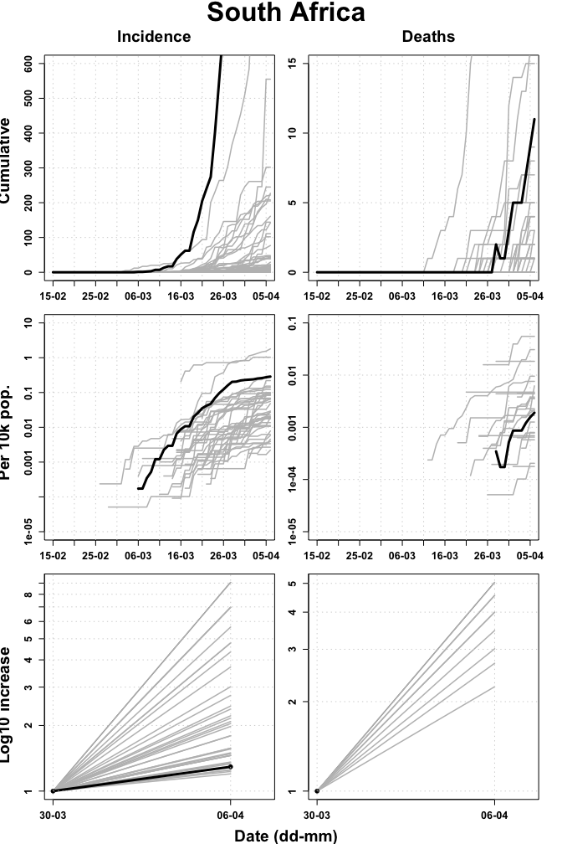

## South Sudan

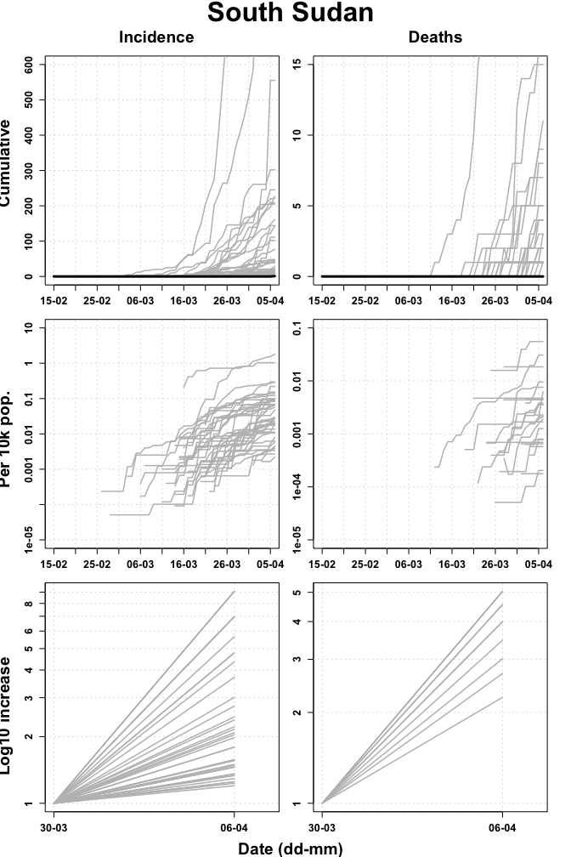

## Togo

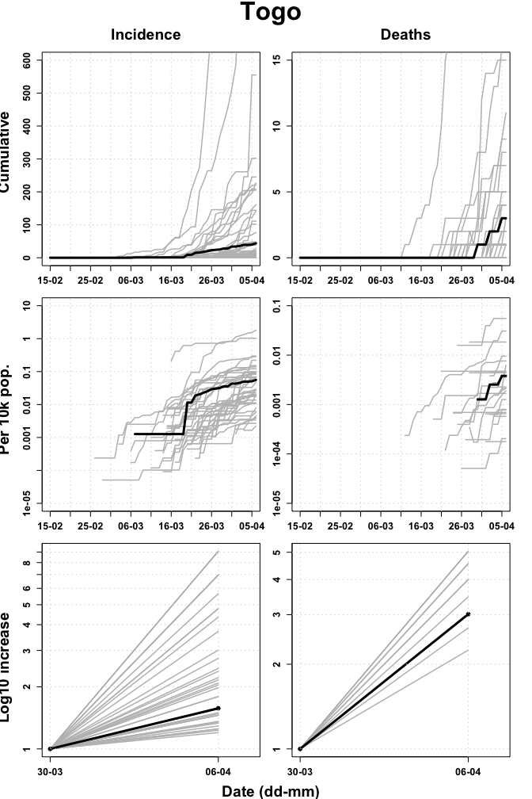

## Uganda

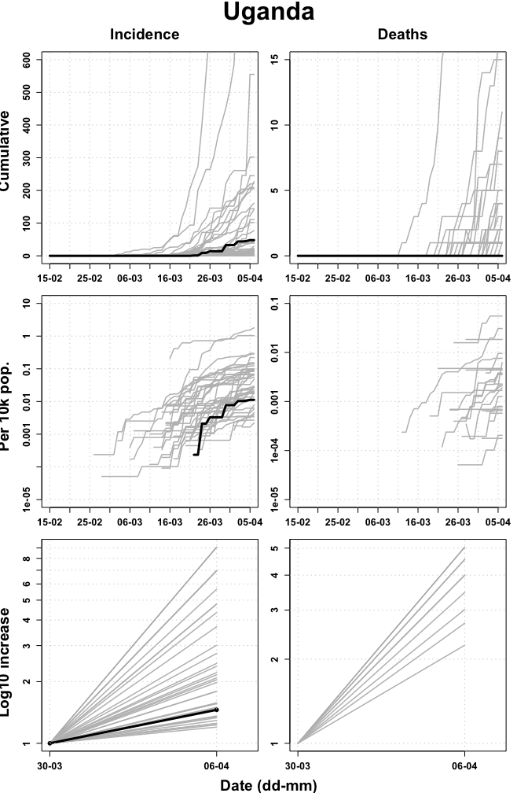

## United Republic of Tanzania

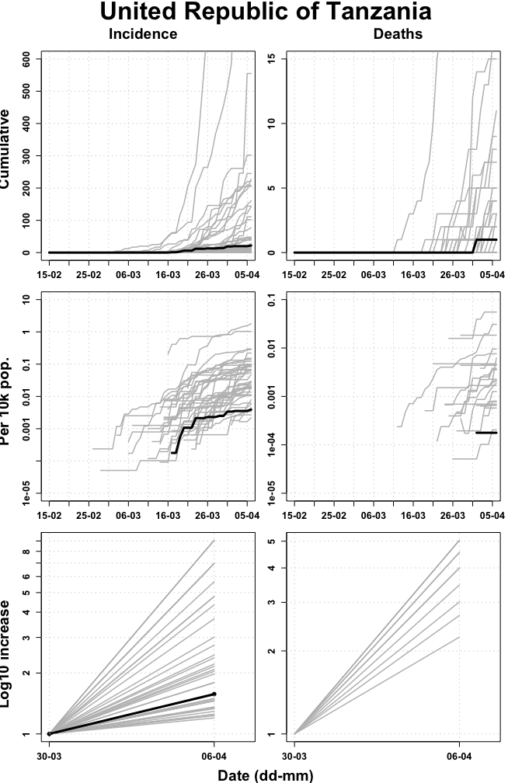

## Zambia

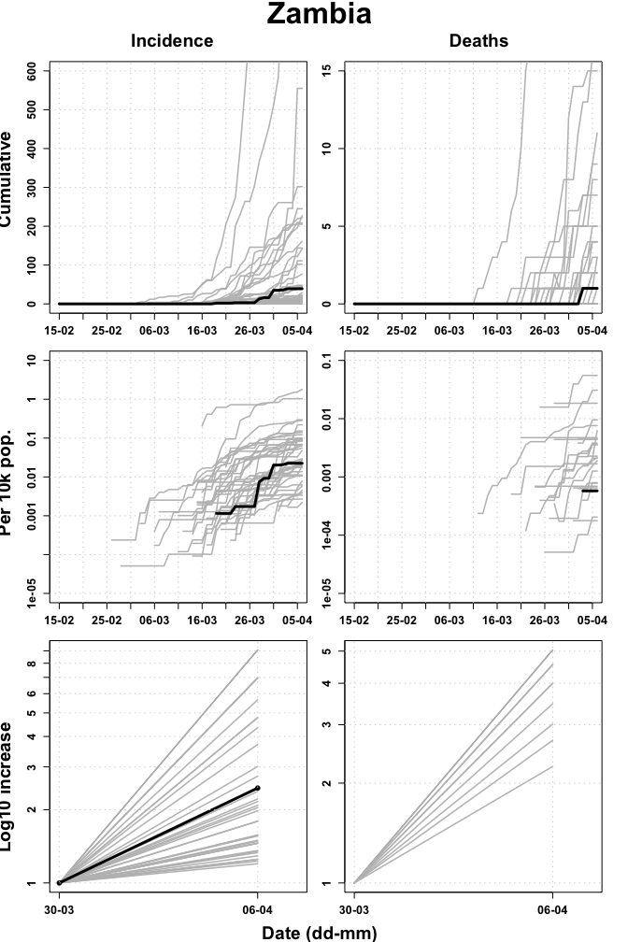

## Zimbabwe

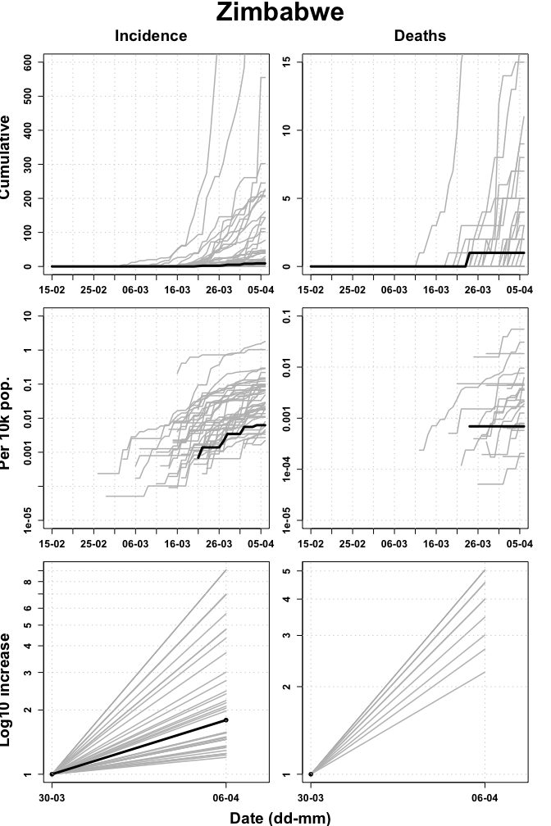

# Appendix

## Data

### Sources and access

* Case counts for countries in WHO African region from WHO Coronavirus disease (COVID-2019) situation reports <https://www.who.int/emergencies/diseases/novel-coronavirus-2019/situation-reports> (accessed 2400 06/04/2020).
* Death counts for countries in WHO African region from WHO Coronavirus disease (COVID-2019) situation reports <https://www.who.int/emergencies/diseases/novel-coronavirus-2019/situation-reports> (accessed 2400 06/04/2020).
* Population counts from the World Bank (2018) <https://data.worldbank.org/indicator/SP.POP.TOTL?locations=ZG> (accessed 0900 30/03/2020).

### Doubling time calculations

Calculated over prior 7 days using method described by *E. Vynnycky & R. White (2010) An Introduction to Infectious Disease Modelling*, page 74.

Confidence intervals calculated using bootstrapping of a simulated dataset with Poisson error structure, using method published here: <https://doi.org/10.1101/2020.02.05.20020750>.

### Caveats

* Case count data are affected by any changes in testing strategy or testing effort over time and/or any variation in testing strategy or testing effort between regions.
* Case count data are likely a substantial under-representation of the true number of COVID-19 infections.
* Death data are considered more reliable but may lag behind case data by as much as 3 weeks.

## Extended data tables

### Cumulative incidence

|  |  |  |  |
| --- | --- | --- | --- |
| Country | Cum. Incidence | ci.low | ci.upp |
| South Africa | 1655 | 1586 | 1720 |
| Algeria | 1251 | 1191 | 1310 |
| Cameroon | 556 | NA | NA |
| Burkina Faso | 302 | 273 | 330 |
| Cote d’Ivoire | 245 | 221 | 272 |
| Mauritius | 227 | 205 | 252 |
| Senegal | 222 | 197 | 245 |
| Ghana | 205 | 183 | 229 |
| Nigeria | 199 | 175 | 223 |
| Democratic Republic of the Congo | 161 | 138 | 181 |
| Niger | 144 | 125 | 163 |
| Kenya | 142 | 122 | 162 |
| Guinea | 111 | 94 | 129 |
| Rwanda | 102 | 86 | 119 |
| Madagascar | 77 | 63 | 93 |
| Uganda | 48 | 37 | 60 |
| Congo | 45 | 34 | 56 |
| Togo | 44 | 34 | 56 |
| Ethiopia | 43 | 32 | 53 |
| Mali | 39 | 29 | 50 |
| Zambia | 39 | 28 | 50 |
| Eritrea | 29 | 21 | 37 |
| Benin | 22 | 14 | 29 |
| United Republic of Tanzania | 22 | 15 | 30 |
| Gabon | 21 | 14 | 29 |
| Guinea Bissau | 18 | 12 | 25 |
| Equatorial Guinea | 16 | 10 | 23 |
| Namibia | 16 | 10 | 23 |
| Angola | 14 | 8 | 20 |
| Liberia | 13 | 7 | 19 |
| Mozambique | 10 | 5 | 16 |
| Seychelles | 10 | 5 | 15 |
| Central African Republic | 9 | 4 | 14 |
| Chad | 9 | 4 | 14 |
| Eswatini | 9 | 5 | 14 |
| Zimbabwe | 9 | 4 | 14 |
| Mauritania | 6 | 2 | 10 |
| Sierra Leone | 6 | 3 | 10 |
| Cape Verde | 5 | 2 | 9 |
| Botswana | 4 | 1 | 7 |
| Gambia | 4 | 1 | 7 |
| Malawi | 4 | 1 | 8 |
| Burundi | 3 | 0 | 6 |
| South Sudan | 1 | 0 | 3 |
| Comoros | 0 | NA | NA |
| Lesotho | 0 | NA | NA |
| Sao Tome and Principe | 0 | NA | NA |

### Cumulative incidence per 10,000 population

|  |  |  |  |
| --- | --- | --- | --- |
| Country | Cum. Incidence per 10k pop. | ci.low | ci.upp |
| Cameroon | 10.2250 | NA | NA |
| Mauritius | 1.7940 | 1.6202 | 1.9916 |
| Seychelles | 1.0335 | 0.5167 | 1.5502 |
| Algeria | 0.2962 | 0.2820 | 0.3102 |
| South Africa | 0.2864 | 0.2745 | 0.2977 |
| Burkina Faso | 0.1529 | 0.1382 | 0.1671 |
| Senegal | 0.1400 | 0.1243 | 0.1545 |
| Equatorial Guinea | 0.1222 | 0.0764 | 0.1757 |
| Gabon | 0.0991 | 0.0661 | 0.1368 |
| Cote d’Ivoire | 0.0977 | 0.0882 | 0.1085 |
| Guinea Bissau | 0.0960 | 0.0640 | 0.1334 |
| Guinea | 0.0894 | 0.0757 | 0.1039 |
| Congo | 0.0858 | 0.0648 | 0.1068 |
| Rwanda | 0.0829 | 0.0699 | 0.0967 |
| Ghana | 0.0689 | 0.0615 | 0.0769 |
| Eswatini | 0.0658 | 0.0366 | 0.1024 |
| Namibia | 0.0654 | 0.0408 | 0.0939 |
| Niger | 0.0642 | 0.0557 | 0.0726 |
| Togo | 0.0558 | 0.0431 | 0.0710 |
| Eritrea | 0.0479 | 0.0347 | 0.0612 |
| Madagascar | 0.0293 | 0.0240 | 0.0354 |
| Kenya | 0.0276 | 0.0237 | 0.0315 |
| Liberia | 0.0270 | 0.0145 | 0.0394 |
| Zambia | 0.0225 | 0.0161 | 0.0288 |
| Mali | 0.0204 | 0.0152 | 0.0262 |
| Central African Republic | 0.0193 | 0.0086 | 0.0300 |
| Benin | 0.0192 | 0.0122 | 0.0253 |
| Democratic Republic of the Congo | 0.0192 | 0.0164 | 0.0215 |
| Botswana | 0.0177 | 0.0044 | 0.0311 |
| Gambia | 0.0175 | 0.0044 | 0.0307 |
| Mauritania | 0.0136 | 0.0045 | 0.0227 |
| Uganda | 0.0112 | 0.0087 | 0.0140 |
| Nigeria | 0.0102 | 0.0089 | 0.0114 |
| Sierra Leone | 0.0078 | 0.0039 | 0.0131 |
| Zimbabwe | 0.0062 | 0.0028 | 0.0097 |
| Chad | 0.0058 | 0.0026 | 0.0090 |
| Angola | 0.0045 | 0.0026 | 0.0065 |
| Ethiopia | 0.0039 | 0.0029 | 0.0049 |
| United Republic of Tanzania | 0.0039 | 0.0027 | 0.0053 |
| Mozambique | 0.0034 | 0.0017 | 0.0054 |
| Burundi | 0.0027 | 0.0000 | 0.0054 |
| Malawi | 0.0022 | 0.0006 | 0.0044 |
| Cape Verde | 0.0020 | 0.0008 | 0.0036 |
| South Sudan | 0.0009 | 0.0000 | 0.0027 |
| Comoros | 0 | NA | NA |
| Lesotho | 0 | NA | NA |
| Sao Tome and Principe | 0 | NA | NA |

### Cumulative deaths

|  |  |
| --- | --- |
| Country | Cum. Num. Deaths |
| Algeria | 130 |
| Democratic Republic of the Congo | 18 |
| Burkina Faso | 15 |
| South Africa | 11 |
| Cameroon | 9 |
| Niger | 8 |
| Mauritius | 7 |
| Congo | 5 |
| Ghana | 5 |
| Kenya | 4 |
| Mali | 4 |
| Nigeria | 4 |
| Liberia | 3 |
| Togo | 3 |
| Angola | 2 |
| Cote d’Ivoire | 2 |
| Senegal | 2 |
| Botswana | 1 |
| Cabo Verde | 1 |
| Ethiopia | 1 |
| Gabon | 1 |
| Gambia | 1 |
| Mauritania | 1 |
| United Republic of Tanzania | 1 |
| Zambia | 1 |
| Zimbabwe | 1 |
| Benin | 0 |
| Burundi | 0 |
| Central African Republic | 0 |
| Chad | 0 |
| Comoros | 0 |
| Equatorial Guinea | 0 |
| Eritrea | 0 |
| Eswatini | 0 |
| Guinea | 0 |
| Guinea-Bissau | 0 |
| Lesotho | 0 |
| Madagascar | 0 |
| Malawi | 0 |
| Mozambique | 0 |
| Namibia | 0 |
| Rwanda | 0 |
| Sao Tome and Principe | 0 |
| Seychelles | 0 |
| Sierra Leone | 0 |
| South Sudan | 0 |
| Uganda | 0 |

### Cumulative deaths per 10,000 populations

|  |  |
| --- | --- |
| Country | Cum. Num. Deaths per 10k pop. |
| Mauritius | 0.0553 |
| Algeria | 0.0308 |
| Cabo Verde | 0.0184 |
| Congo | 0.0095 |
| Burkina Faso | 0.0076 |
| Liberia | 0.0062 |
| Gabon | 0.0047 |
| Botswana | 0.0044 |
| Gambia | 0.0044 |
| Togo | 0.0038 |
| Cameroon | 0.0036 |
| Niger | 0.0036 |
| Mauritania | 0.0023 |
| Democratic Republic of the Congo | 0.0021 |
| Mali | 0.0021 |
| South Africa | 0.0019 |
| Ghana | 0.0017 |
| Senegal | 0.0013 |
| Cote d’Ivoire | 0.0008 |
| Kenya | 0.0008 |
| Zimbabwe | 0.0007 |
| Angola | 0.0006 |
| Zambia | 0.0006 |
| Nigeria | 0.0002 |
| United Republic of Tanzania | 0.0002 |
| Ethiopia | 0.0001 |
| Benin | 0.0000 |
| Burundi | 0.0000 |
| Central African Republic | 0.0000 |
| Chad | 0.0000 |
| Comoros | 0.0000 |
| Equatorial Guinea | 0.0000 |
| Eritrea | 0.0000 |
| Eswatini | 0.0000 |
| Guinea | 0.0000 |
| Guinea-Bissau | 0.0000 |
| Lesotho | 0.0000 |
| Madagascar | 0.0000 |
| Malawi | 0.0000 |
| Mozambique | 0.0000 |
| Namibia | 0.0000 |
| Rwanda | 0.0000 |
| Sao Tome and Principe | 0.0000 |
| Seychelles | 0.0000 |
| Sierra Leone | 0.0000 |
| South Sudan | 0.0000 |
| Uganda | 0.0000 |

### Doubling time (incidence)

|  |  |  |  |  |  |  |
| --- | --- | --- | --- | --- | --- | --- |
|  | country | Td.obs | ci.low | ci.upp | t1 | t2 |
| 23 | Guinea-Bissau | 2.2 | 1.6 | 3.4 | 2020-03-30 | 2020-04-06 |
| 2 | Angola | 2.5 | 1.8 | 4.4 | 2020-03-30 | 2020-04-06 |
| 22 | Guinea | 2.5 | 2.0 | 3.0 | 2020-03-30 | 2020-04-06 |
| 34 | Niger | 2.5 | 2.0 | 2.9 | 2020-03-30 | 2020-04-06 |
| 24 | Kenya | 2.8 | 2.3 | 3.3 | 2020-03-30 | 2020-04-06 |
| 8 | Cameroon | 3.1 | NA | NA | 2020-03-30 | 2020-04-06 |
| 16 | Eritrea | 3.1 | 2.0 | 4.5 | 2020-03-30 | 2020-04-06 |
| 26 | Liberia | 3.3 | 2.0 | 6.0 | 2020-03-30 | 2020-04-06 |
| 3 | Benin | 3.7 | 2.3 | 6.0 | 2020-03-30 | 2020-04-06 |
| 19 | Gabon | 4.4 | 2.6 | 7.4 | 2020-03-30 | 2020-04-06 |
| 1 | Algeria | 4.8 | 4.5 | 5.1 | 2020-03-30 | 2020-04-06 |
| 46 | Zambia | 5.4 | 3.8 | 8.1 | 2020-03-30 | 2020-04-06 |
| 12 | Congo | 5.6 | 4.0 | 8.0 | 2020-03-30 | 2020-04-06 |
| 31 | Mauritius | 6.1 | 5.3 | 7.0 | 2020-03-30 | 2020-04-06 |
| 29 | Mali | 6.3 | 4.4 | 9.4 | 2020-03-30 | 2020-04-06 |
| 27 | Madagascar | 6.6 | 5.2 | 8.8 | 2020-03-30 | 2020-04-06 |
| 18 | Ethiopia | 6.8 | 4.7 | 10.1 | 2020-03-30 | 2020-04-06 |
| 14 | Democratic Republic of the Congo | 7.1 | 5.9 | 8.6 | 2020-03-30 | 2020-04-06 |
| 10 | Chad | 8.3 | 3.9 | 27.3 | 2020-03-30 | 2020-04-06 |
| 47 | Zimbabwe | 8.3 | 3.5 | 26.6 | 2020-03-30 | 2020-04-06 |
| 43 | Togo | 10.7 | 7.2 | 17.4 | 2020-03-30 | 2020-04-06 |
| 45 | United Republic of Tanzania | 10.7 | 6.2 | 23.0 | 2020-03-30 | 2020-04-06 |
| 38 | Senegal | 10.9 | 9.0 | 13.3 | 2020-03-30 | 2020-04-06 |
| 9 | Central African Republic | 12.0 | 5.3 | 46.1 | 2020-03-30 | 2020-04-06 |
| 13 | Cote d’Ivoire | 12.3 | 10.2 | 14.9 | 2020-03-30 | 2020-04-06 |
| 33 | Namibia | 12.9 | 6.4 | 33.9 | 2020-03-30 | 2020-04-06 |
| 36 | Rwanda | 12.9 | 9.6 | 17.5 | 2020-03-30 | 2020-04-06 |
| 44 | Uganda | 12.9 | 8.8 | 20.9 | 2020-03-30 | 2020-04-06 |
| 5 | Burkina Faso | 15.8 | 13.1 | 19.3 | 2020-03-30 | 2020-04-06 |
| 21 | Ghana | 16.2 | 13.2 | 20.8 | 2020-03-30 | 2020-04-06 |
| 20 | Gambia | 16.9 | 5.3 | Inf | 2020-03-30 | 2020-04-06 |
| 41 | South Africa | 18.9 | 17.4 | 20.7 | 2020-03-30 | 2020-04-06 |
| 32 | Mozambique | 21.7 | 8.7 | Inf | 2020-03-30 | 2020-04-06 |
| 39 | Seychelles | 21.7 | 8.0 | Inf | 2020-03-30 | 2020-04-06 |
| 15 | Equatorial Guinea | 23.4 | 10.3 | Inf | 2020-03-30 | 2020-04-06 |
| 30 | Mauritania | 26.6 | 7.0 | Inf | 2020-03-30 | 2020-04-06 |
| 7 | Cabo Verde | Inf | Inf | Inf | 2020-03-30 | 2020-04-06 |
| 17 | Eswatini | Inf | Inf | Inf | 2020-03-30 | 2020-04-06 |
| 4 | Botswana | NA | NA | NA | 2020-03-30 | 2020-04-06 |
| 6 | Burundi | NA | NA | NA | 2020-03-30 | 2020-04-06 |
| 11 | Comoros | NA | NA | NA | 2020-03-30 | 2020-04-06 |
| 25 | Lesotho | NA | NA | NA | 2020-03-30 | 2020-04-06 |
| 28 | Malawi | NA | NA | NA | 2020-03-30 | 2020-04-06 |
| 35 | Nigeria | NA | NA | NA | 2020-03-30 | 2020-04-06 |
| 37 | Sao Tome and Principe | NA | NA | NA | 2020-03-30 | 2020-04-06 |
| 40 | Sierra Leone | NA | NA | NA | 2020-03-30 | 2020-04-06 |
| 42 | South Sudan | NA | NA | NA | 2020-03-30 | 2020-04-06 |

### Doubling time (deaths)

|  |  |  |  |  |  |  |
| --- | --- | --- | --- | --- | --- | --- |
|  | country | Td.obs | ci.low | ci.upp | t1 | t2 |
| 5 | Burkina Faso | 3.0 | 1.8 | 5.1 | 2020-03-30 | 2020-04-06 |
| 1 | Algeria | 3.2 | 2.7 | 3.9 | 2020-03-30 | 2020-04-06 |
| 8 | Cameroon | 3.2 | 2.0 | 7.0 | 2020-03-30 | 2020-04-06 |
| 24 | Kenya | 3.5 | 2.7 | 20.5 | 2020-03-30 | 2020-04-06 |
| 35 | Nigeria | 3.5 | 2.7 | Inf | 2020-03-30 | 2020-04-06 |
| 31 | Mauritius | 3.9 | 2.3 | 10.3 | 2020-03-30 | 2020-04-06 |
| 43 | Togo | 4.4 | 3.0 | Inf | 2020-03-30 | 2020-04-06 |
| 34 | Niger | 4.9 | 2.5 | 12.0 | 2020-03-30 | 2020-04-06 |
| 14 | Democratic Republic of the Congo | 6.0 | 3.7 | 11.1 | 2020-03-30 | 2020-04-06 |
| 7 | Cabo Verde | Inf | Inf | Inf | 2020-03-30 | 2020-04-06 |
| 19 | Gabon | Inf | Inf | Inf | 2020-03-30 | 2020-04-06 |
| 20 | Gambia | Inf | Inf | Inf | 2020-03-30 | 2020-04-06 |
| 21 | Ghana | Inf | Inf | Inf | 2020-03-30 | 2020-04-06 |
| 47 | Zimbabwe | Inf | Inf | Inf | 2020-03-30 | 2020-04-06 |
| 2 | Angola | NA | NA | NA | 2020-03-30 | 2020-04-06 |
| 3 | Benin | NA | NA | NA | 2020-03-30 | 2020-04-06 |
| 4 | Botswana | NA | NA | NA | 2020-03-30 | 2020-04-06 |
| 6 | Burundi | NA | NA | NA | 2020-03-30 | 2020-04-06 |
| 9 | Central African Republic | NA | NA | NA | 2020-03-30 | 2020-04-06 |
| 10 | Chad | NA | NA | NA | 2020-03-30 | 2020-04-06 |
| 11 | Comoros | NA | NA | NA | 2020-03-30 | 2020-04-06 |
| 12 | Congo | NA | NA | NA | 2020-03-30 | 2020-04-06 |
| 13 | Cote d’Ivoire | NA | NA | NA | 2020-03-30 | 2020-04-06 |
| 15 | Equatorial Guinea | NA | NA | NA | 2020-03-30 | 2020-04-06 |
| 16 | Eritrea | NA | NA | NA | 2020-03-30 | 2020-04-06 |
| 17 | Eswatini | NA | NA | NA | 2020-03-30 | 2020-04-06 |
| 18 | Ethiopia | NA | NA | NA | 2020-03-30 | 2020-04-06 |
| 22 | Guinea | NA | NA | NA | 2020-03-30 | 2020-04-06 |
| 23 | Guinea-Bissau | NA | NA | NA | 2020-03-30 | 2020-04-06 |
| 25 | Lesotho | NA | NA | NA | 2020-03-30 | 2020-04-06 |
| 26 | Liberia | NA | NA | NA | 2020-03-30 | 2020-04-06 |
| 27 | Madagascar | NA | NA | NA | 2020-03-30 | 2020-04-06 |
| 28 | Malawi | NA | NA | NA | 2020-03-30 | 2020-04-06 |
| 29 | Mali | NA | NA | NA | 2020-03-30 | 2020-04-06 |
| 30 | Mauritania | NA | NA | NA | 2020-03-30 | 2020-04-06 |
| 32 | Mozambique | NA | NA | NA | 2020-03-30 | 2020-04-06 |
| 33 | Namibia | NA | NA | NA | 2020-03-30 | 2020-04-06 |
| 36 | Rwanda | NA | NA | NA | 2020-03-30 | 2020-04-06 |
| 37 | Sao Tome and Principe | NA | NA | NA | 2020-03-30 | 2020-04-06 |
| 38 | Senegal | NA | NA | NA | 2020-03-30 | 2020-04-06 |
| 39 | Seychelles | NA | NA | NA | 2020-03-30 | 2020-04-06 |
| 40 | Sierra Leone | NA | NA | NA | 2020-03-30 | 2020-04-06 |
| 41 | South Africa | NA | NA | NA | 2020-03-30 | 2020-04-06 |
| 42 | South Sudan | NA | NA | NA | 2020-03-30 | 2020-04-06 |
| 44 | Uganda | NA | NA | NA | 2020-03-30 | 2020-04-06 |
| 45 | United Republic of Tanzania | NA | NA | NA | 2020-03-30 | 2020-04-06 |
| 46 | Zambia | NA | NA | NA | 2020-03-30 | 2020-04-06 |